COS 226 Algorithms and Data Structures Fall 2011

Final
This test has 14 questions worth a total of 100 points. You have 180 minutes. The exam is closed book, except that you are allowed to use a one page cheatsheet (8.5-by-11, both sides, in your own handwriting). No calculators or other electronic devices are permitted. Give your answers and show your work in the space provided. Write out and sign the Honor Code pledge before turning in the test.
“I pledge my honor that I have not violated the Honor Code during this examination.”

Problem
Score
Problem
Score
0
7
1
8
2
9
3
10
4
11
5
12
6
13
Sub 1
Sub 2
Total
Name:
Login ID:
Precept:
P01 11 Maia Ginsburg P01A 11 Aman Dhesi P02 12:30 Sasha Koruga P02A 12:30 Joey Dodds P03 1:30 Maia Ginsburg
P03A 1:30 Joey Dodds
1
0. Miscellaneous. (1 point)
Write your name and Princeton NetID in the space provided on the front of the exam, and circle your precept number.
1. Analysis of algorithms. (10 points)
(a) Suppose that you collect the following memory usage data for a program as a function
of the input size N. N
1,000 | 10,000 bytes
8,000 | 320,000 bytes
64,000 | 10,240,000 bytes
512,000 | 327,680,000 bytes

memory
Estimate the memory usage of the program (in bytes) as a function of N and use tilde notation to simplify your answer. Hint: recall that logb a = lg a/ lg b.
(b) For each function on the left, give the best matching order of growth of the running time on the right.
COS 226 FINAL, FALL 2011
−−B−− | public static int x = 0; for (int i x++; return x; } | int f1(int N) { = 0; i < N; i++) |  |  | A. log N B. N C. N log N
−−−−− | public static int f2(int N) { int x = 0; for (int i = 0; i < N; i++) for (int j = 0; j < i; j++) x++; return x; } |  |  |  | D. N2 E. 2N F. N!
−−−−− | public static int f3(int N) { if (N == 0) return 1; int x = 0; for (int i = 0; i < N; i++) x += f3(N-1); return x; }
−−−−− | public static int f4(int N) { if (N == 0) return 0; return f4(N/2) + f1(N) + f4(N/2); }
−−−−− | public static int f5(int N) int x = 0; for (int i = N; i > 0; i x += f1(i); return x; } |  | { = | i/2)
−−−−− | public static int f6(int N) { if (N == 0) return 1; return f6(N-1) + f6(N-1); }

−−−−− public static int f7(int N) { if (N == 1) return 0; return 1 + f7(N/2); }
2. Graph search. (8 points) Consider the following acyclic digraph. Assume the adjacency lists are in sorted order: for
example, when iterating through the edges pointing from 0, consider the edge 0 → 1 before 0 → 6 or 0 → 7.
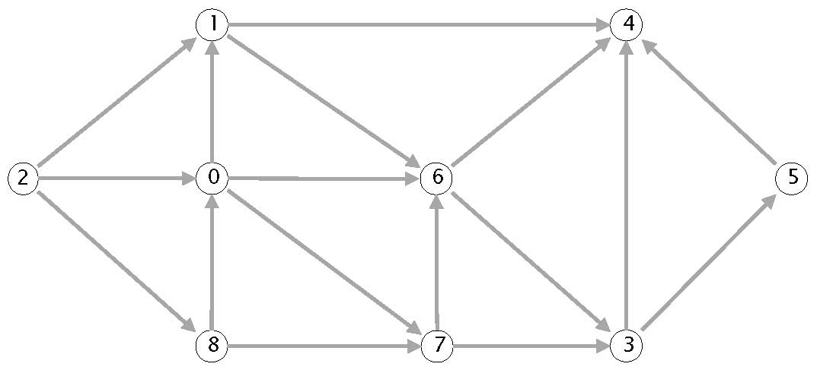
(a) Compute the topological order by running the DFS-based algorithm and listing the vertices in reverse postorder.
(b) Run breadth-ﬁrst search on the digraph, starting from vertex 2. List the vertices in the order in which they are dequeued from the FIFO queue.

2
2
3. Minimum spanning trees. (8 points)
Consider the following edge-weighted graph with 9 vertices and 19 edges. Note that the edge weights are distinct integers between 1 and 19.
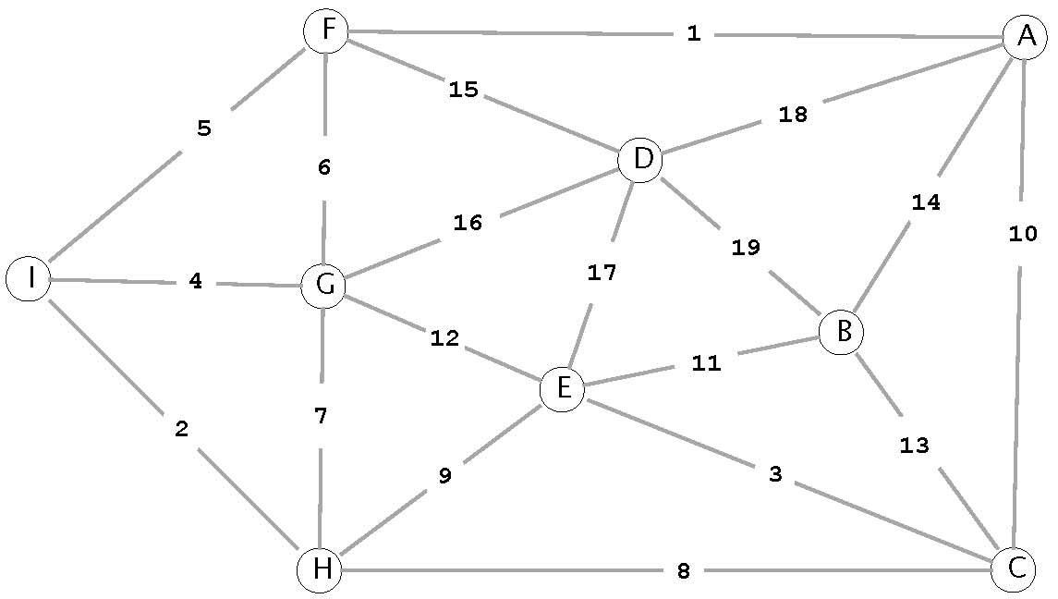
(a) Complete the sequence of edges in the MST in the order that Kruskal’s algorithm includes them (by specifying their edge weights).
(b) Complete the sequence of edges in the MST in the order that Prim’s algorithm includes them (by specifying their edge weights).

1
1
4. Shortest paths. (8 points) Suppose that you are running Dijkstra’s algorithm on the edge-weighted digraph (below left),
starting from a source vertex s. The table (below right) gives the edgeTo[] and distTo[] values immediately after vertex 2 has been deleted from the priority queue and relaxed.
edge weight edge weight
0 → 2 | 6.0 | 5 → 1 | 12.0
0 → 4 | 6.0 | 5 → 2 | 1.0
0 → 5 | 17.0 | 5 → 4 | 3.0
1 → 3 | 17.0 | 5 → 7 | 10.0
2 → 5 | 11.0 | 5 → 8 | 4.0
2 → 7 | 6.0 | 6 → 0 | 12.0
3 → 0 | 1.0 | 6 → 1 | 5.0
3 → 10 | 3.0 | 6 → 2 | 1.0
3 → 1 | 25.0 | 6 → 4 | 9.0
3 → 6 | 13.0 | 6 → 9 | 4.0
3 → 8 | 9.0 | 7 → 1 | 7.0
4 → 5 | 3.0 | 7 → 5 | 11.0
4 → 6 | 4.0 | 7 → 9 | 6.0
4 → 7 | 3.0 | 10 → 1 | 15.0
4 → 8 | 1.0 | 10 → 5 | 2.0

v | distTo[] | edgeTo[]
0 | 1.0 | 3 → 0
1 | 17.0 | 5 → 1
2 | 6.0 | 5 → 2
3 | 0.0 | null
4 | 7.0 | 0 → 4
5 | 5.0 | 10 → 5
6 | 13.0 | 3 → 6
7 | 12.0 | 2 → 7
8 | 9.0 | 3 → 8
9 | ∞ | null
10 | 3.0 | 3 → 10

4 → 9 15.0 10 → 8 7.0
(a) Give the order in which the ﬁrst 5 vertices were deleted from the priority queue and relaxed.
(b) Modify the table (above right) to show the values of the edgeTo[] and distTo[] arrays immediately after the next vertex has been deleted from the priority queue and relaxed. Circle those values that changed.

2

5. String sorting. (6 points) Consider the ﬁrst call to key-indexed counting when running LSD string sort on the input array a[] of 20 strings. Recall that key-indexed counting is comprised of four loops. Give the contents of the integer array count[] after each of the ﬁrst three loops (for indices between
'a' and 'g'); then, give the contents of the string array (for the indices 0–5 and 18–19) after the fourth loop.
i | a[i]
0 | badge
1 | freed
2 | blurb
3 | embed
4 | basic
5 | field
6 | bluff
7 | dwarf
8 | fudge
9 | climb
10 | cycle
11 | bleed
12 | budge
13 | crumb
14 | cubic
15 | cable
16 | blend
17 | cliff
18 | bread
19 | cache

c | count[] (ﬁrst) | count[] (second) | count[] (third)
... | ... | ... | ...
'a'
'b'
'c'
'd'
'e'
'f'
'g'
... | ... | ... | ...

i | a[i] (fourth)
0
1
2
3
4
5
6 | not required
7 | not required
8 | not required
9 | not required
10 | not required
11 | not required
12 | not required
13 | not required
14 | not required
15 | not required
16 | not required
17 | not required
18
19

6. Substring search. (6 points)
Below is a partially-completed Knuth-Morris-Pratt DFA for a string s of length 11 over the alphabet { A , B }. Reconstruct the DFA and s in the space below.
 | 0 | 1 | 2 | 3 | 4 | 5 | 6 | 7 | 8 | 9 | 10
A B | 0 | 0 |  |  | 5 |  | 2 |  |  | 10 | 11 4
s |  |  |  |  |  |  |  |  |  | A

7. Regular expressions. (5 points) You have been promoted to COS 226 grader. Circle each NFA below that could have been
constructed by the RE-to-NFA algorithm from the textbook. Otherwise, explain one mistake in each invalid NFA. The match transitions are drawn with solid lines; the E-transitions are drawn with dotted
lines.
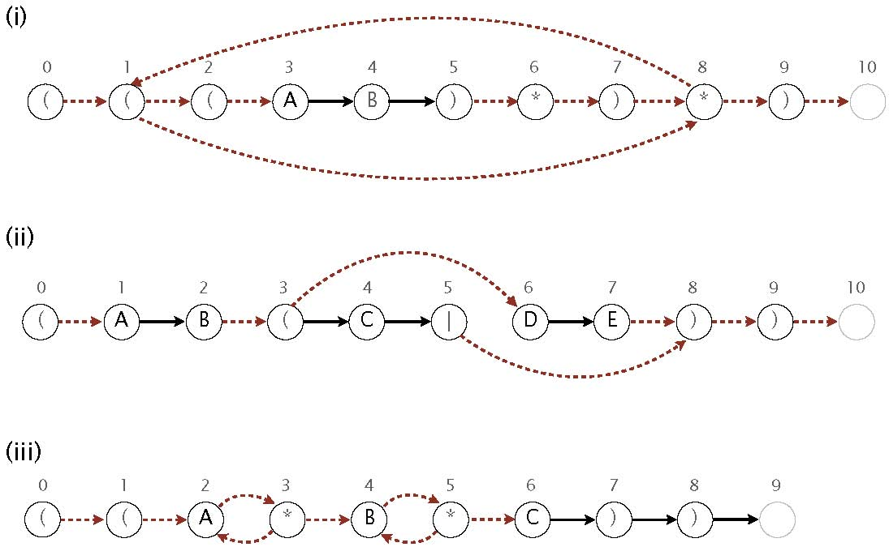
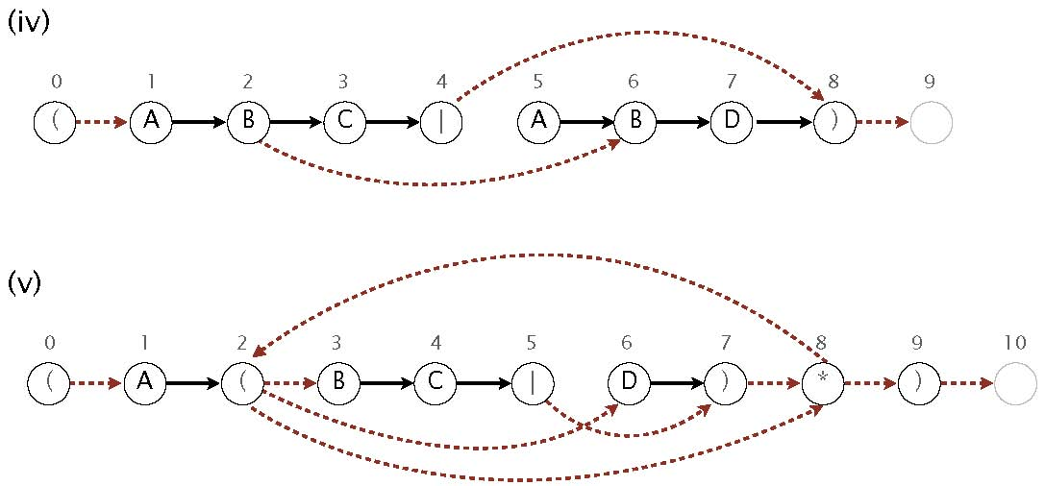
8. Ternary search tries. (7 points) Consider the following ternary search trie, with string keys and integer values.
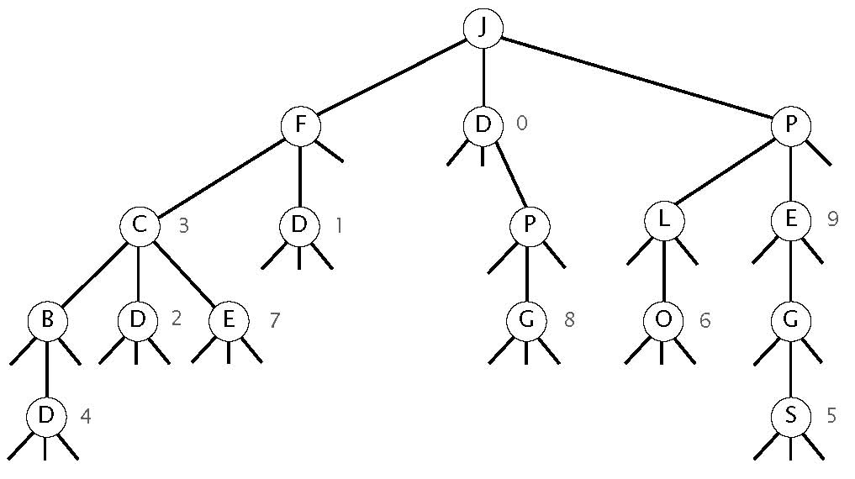
Circle which one or more of the following strings are keys in the TST.
B BD C CD D E FD JLO JP JPEG JPEGS JPG PEG PEGS
9. String symbol table implementation. (7 points) For each of the operations on the left, list which one or more of the symbol table implementations on the right can be used to eﬃciently implement it. By eﬃcient, we mean L log N
or better on typical ASCII strings (in random order) of average length L, where N is the number of keys in the data structure.
−−−−− | Find the value associated with a given string key in the data structure. | A. Unordered array.
 |  | B. Ordered array.
−−−−− | Associate a value with a string key. | C. Red-black BST.

−−−−− Delete a string key (and its associated D. Separate-chaining hash table.
value) from the data structure.
E. Ternary search trie.
−−−−− Find the smallest string key in the data structure.
−−−−− Find the smallest string key in the data structure that is greater than or equal to a given string.
−−−−− Find the string key in the data structure that is the longest preﬁx of a given string.
−−−−− How many string keys in the data structure starts with a given preﬁx?
10. Data compression. (10 points)
(a) Consider the following Huﬀman trie of a message over the 5-character alphabet {A, B, C, D, E}:
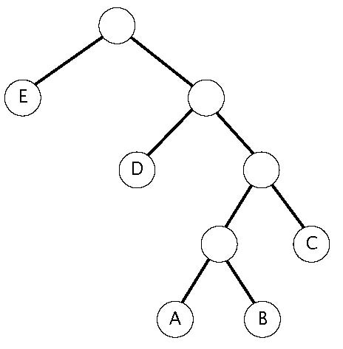
Identify each statement with the best matching description on the right.
−−−− | The frequency of A is strictly less than the fre- | A. True for all messages.
 | quency of B.
 |  | B. False for all messages.
−−−− | The frequency of C is greater than or equal to
 | the frequency of A. | C. Depends on the message.

−−−− The frequency of D is strictly greater than the frequency of A.
−−−− The frequency of D is greater than or equal to that of A, B, and C combined.
−−−− The frequency of E is strictly less than that of A, B, and C combined.
(b) Decode each of the following LZW-encoded messages or explain brieﬂy why it is not a valid LZW-encoded message. (Recall that codeword 80 is reserved to signify end of ﬁle.)
 | encoded message | decoded message or brief explanation of why invalid
 | 41 42 43 44 80 | A B C D
 | 42 41 4E 82 41 80
 | 42 41 83 80
 | 41 42 81 82 80
 | 41 42 81 83 80
42 | 41 4E 44 41 4E 41 80

For reference, below is the hexademical-to-ASCII conversion table from the textbook:
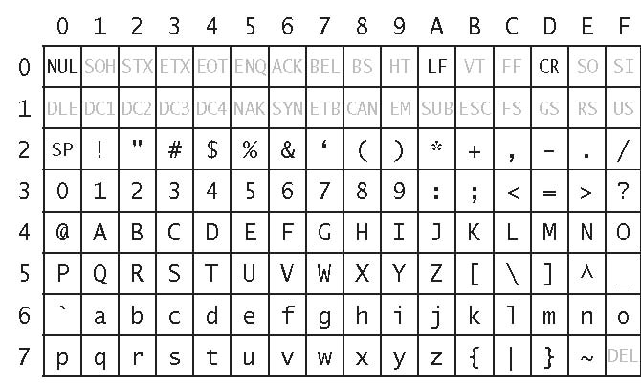
11. Maximum ﬂow. (8 points) Consider the following st-ﬂow network and feasible ﬂow f.
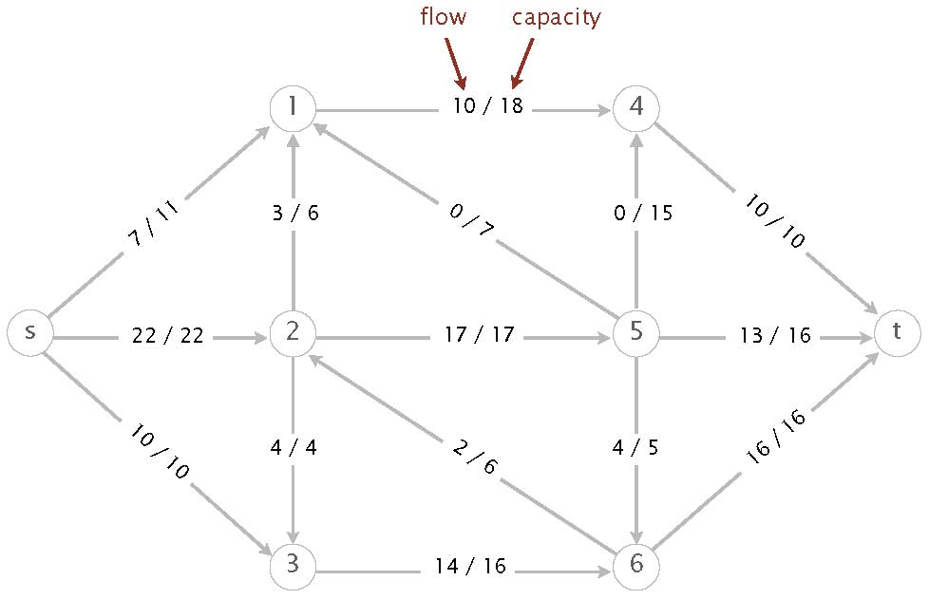
(a) What is the value of the ﬂow f?
(b) Perform one iteration of the Ford-Fulkerson algorithm, starting from the ﬂow f. Give the sequence of vertices on the augmenting path.
(c) What is the value of the maximum ﬂow?
(d) List the vertices on the s side of the minimum cut.
(e) What is the capacity of the minimum cut?

12. Algorithm design. (8 points) Given an edge-weighted graph G and an edge e, design a linear-time algorithm to determine
whether e appears in an MST of G. For simplicity, assume that G is connected and that all edge weights are distinct.
Note: Since your algorithm must take linear time in the worst case, you cannot aﬀord to compute the MST itself.
(a) Describe your algorithm in the space below.
(b) What is the order of growth of the running time of your algorithm in the worst case as a function of the number of vertices V and the number of edges E? Circle the best answer.

1 VE + VE log ∗ VE log E EV 2V
13. Reductions. (8 points) Consider the following two related problems:
- 3Sum. Given an integer array a[], are there three indices i, j, and k (not necessarily distinct) such that a[i] + a[j] + a[k] == 0 ?
- 3SumVariant. Given two integer arrays b[] and c[], are there three indices i, j, and k (not necessarily distinct) such that b[i] + b[j] == c[k] ?

(a) Show that 3Sum linear-time reduces to 3SumVariant. To demonstrate your reduction, give the 3SumVariant instance that would be constructed to solve the following 3Sum instance:
b[]
c[]
(b) Show that 3SumVariant linear-time reduces to 3Sum. To demonstrate your reduction, give the 3Sum instance that would be constructed to solve the following 3SumVariant instance:
c[]
999 | 19 | -4 | 600 | 30 | 20

Hint: deﬁne M equal to 1 + maximum absolute value of any integer in b[] or c[].
a[]
16

